***WHY DID HTML ADD NEW TAGS?***

The HTML5 specification introduced several semantic sectioning elements to help organize the structure of documents.

* Semantic sectioning elements are specifically designed to communicate structural meaning to browsers and other technologies interpreting the document on behalf of users, such as screen readers and voice assistants.
* They are intended to enhance the limited semantics of earlier versions of HTML, which included only the <div> tag as a generic mechanism for grouping related content.

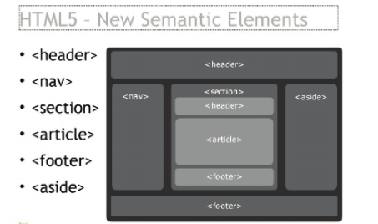

***SECTION ELEMENTS IN HTML:***

**HTML Navigational Element** ([<nav>](https://developer.mozilla.org/en-US/docs/Web/HTML/Element/nav)) defines a section that contains navigation links that appear often on a site. You can have primary and secondary menus, but you cannot nest a <nav> element inside another <nav> element.

**HTML Article Element** ([<article>](https://developer.mozilla.org/en-US/docs/Web/HTML/Element/article)) defines a piece of self-contained content. It does not refer to the main content alone and can be used for comments and widgets.

**HTML Section Element** ([<section>](https://developer.mozilla.org/en-US/docs/Web/HTML/Element/section)) defines a section of a document to indicate a related grouping of semantic meaning. It makes sense to use the section element to provide extra context for the parent element.

**HTML Aside Element** ([<aside>](https://developer.mozilla.org/en-US/docs/Web/HTML/Element/aside)) defines a section that, though related to the main element, doesn't belong to the main flow, like an explanation box or an advertisement. The aside element has its own outline, but doesn't belong to the main one.

**HTML Header Element** ([<header>](https://developer.mozilla.org/en-US/docs/Web/HTML/Element/header)) defines a page area that typically contains a logo, title, and navigation. The header can also be used inside other semantic elements such as <article> or <section>. A section header might contain the section's heading, author name, etc. [<article>](https://developer.mozilla.org/en-US/docs/Web/HTML/Element/article), [<section>](https://developer.mozilla.org/en-US/docs/Web/HTML/Element/section), [<aside>](https://developer.mozilla.org/en-US/docs/Web/HTML/Element/aside), and [<nav>](https://developer.mozilla.org/en-US/docs/Web/HTML/Element/nav) can have their own [<header>](https://developer.mozilla.org/en-US/docs/Web/HTML/Element/header). Despite its name, the header is not necessarily positioned at the beginning of a page or section.

**HTML Footer Element** ([<footer>](https://developer.mozilla.org/en-US/docs/Web/HTML/Element/footer)) defines a page footer, which typically contains copyright or legal notices and sometimes some links. In the context of a section, a footer might contain the sectioned content's publication date, license information, etc. [<article>](https://developer.mozilla.org/en-US/docs/Web/HTML/Element/article), [<section>](https://developer.mozilla.org/en-US/docs/Web/HTML/Element/section), [<aside>](https://developer.mozilla.org/en-US/docs/Web/HTML/Element/aside), and [<nav>](https://developer.mozilla.org/en-US/docs/Web/HTML/Element/nav) can have their own [<footer>](https://developer.mozilla.org/en-US/docs/Web/HTML/Element/footer). Despite its name, the footer is not necessarily positioned at the end of a page or section.

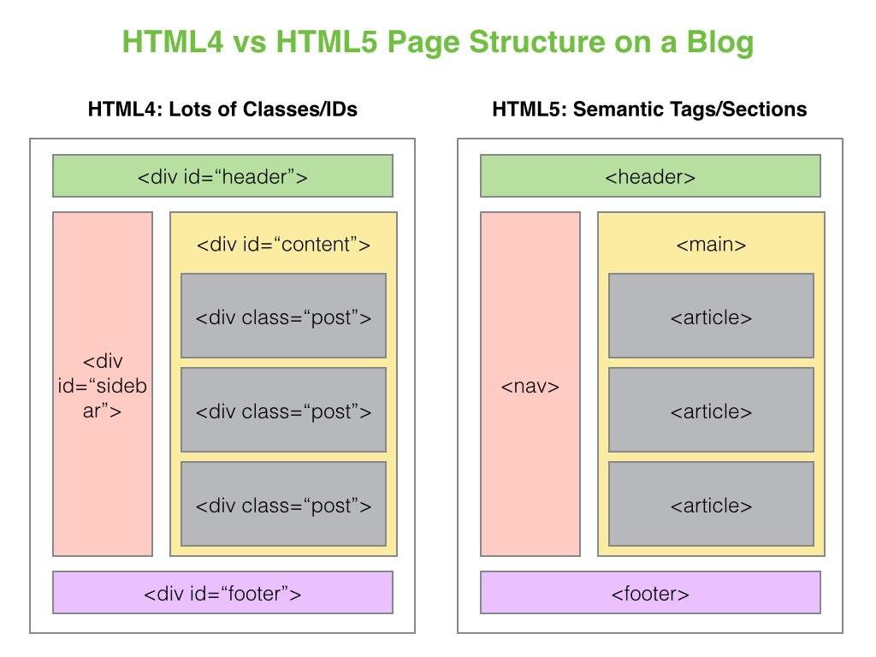

***REASON:***

The new semantic elements introduced in HTML5 bring the ability to describe the structure of a web document in a standard way. They bring a big advantage for people having HTML5 browsers and needing the structure to help them understand the page. These new semantic elements are simple to use and, with very few burdens, can be made to work also in non-HTML5 browsers. Therefore they can be used without restrictions.